7ZzipReplaceWithZips ReadMe

# Overview

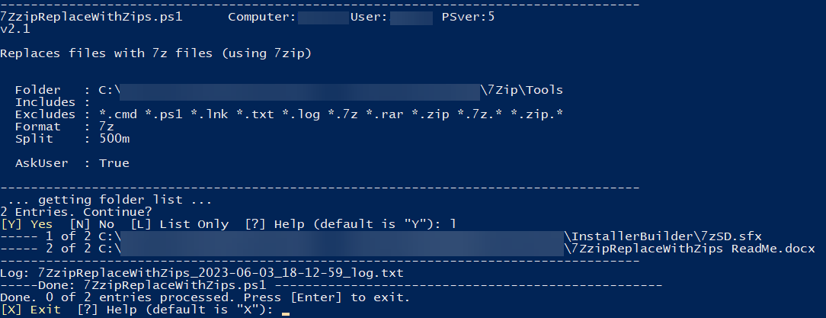

## 7ZzipReplaceWithZips.ps1

Scans through a folder of files and replaces them with compressed versions of themselves.

By default, searches for all files, but you can include (and exclude) any types of files.

By default, zips are split into 500MB chunks.

## 7ZzipReplaceSubfoldersWithZips.ps1

Same as above, except that it replaces subfolders with chunked zips.

## Usage

1. Install 7Zip on the machine (7Zip Download area is [here](https://www.7-zip.org/download.html))
2. Copy the ps1 files into the folder where you want to run it.
3. Edit the ps1 to adjust the file types to search for.
4. Right-click and Run with Powershell